Entity Framework Core Hands-on Labs

Lab 1:Understanding ORM with a Retail Inventory System

Code

1. Product.cs
csharp
CopyEdit
namespace RetailAppEFCore
{
public class Product
{
public int Id { get; set; }
public string? Name { get; set; }
public decimal Price { get; set; }
}
}

2. AppDbContext.cs
csharp
CopyEdit
using Microsoft.EntityFrameworkCore;
namespace RetailAppEFCore
{
public class AppDbContext : DbContext
{
public DbSet<Product> Products { get; set; }

protected override void OnConfiguring(DbContextOptionsBuilder optionsBuilder)
{
optionsBuilder.UseSqlServer(@"Server=(localdb)\mssqllocaldb;Database=RetailInventoryDb;Trusted_Connection=True;");
}
}
}

3. Program.cs
csharp
CopyEdit
using System;using Microsoft.EntityFrameworkCore;
namespace RetailAppEFCore
{
class Program
{
static void Main(string[] args)
{
using (var context = new AppDbContext())
{
var product = new Product
{
Name = "USB Cable",
Price = 249.99m
};

context.Products.Add(product);
context.SaveChanges();

Console.WriteLine("✅ Product saved to the database successfully!");
}

Console.WriteLine("Press any key to exit...");
Console.ReadKey();
}
}
}

Screenshot
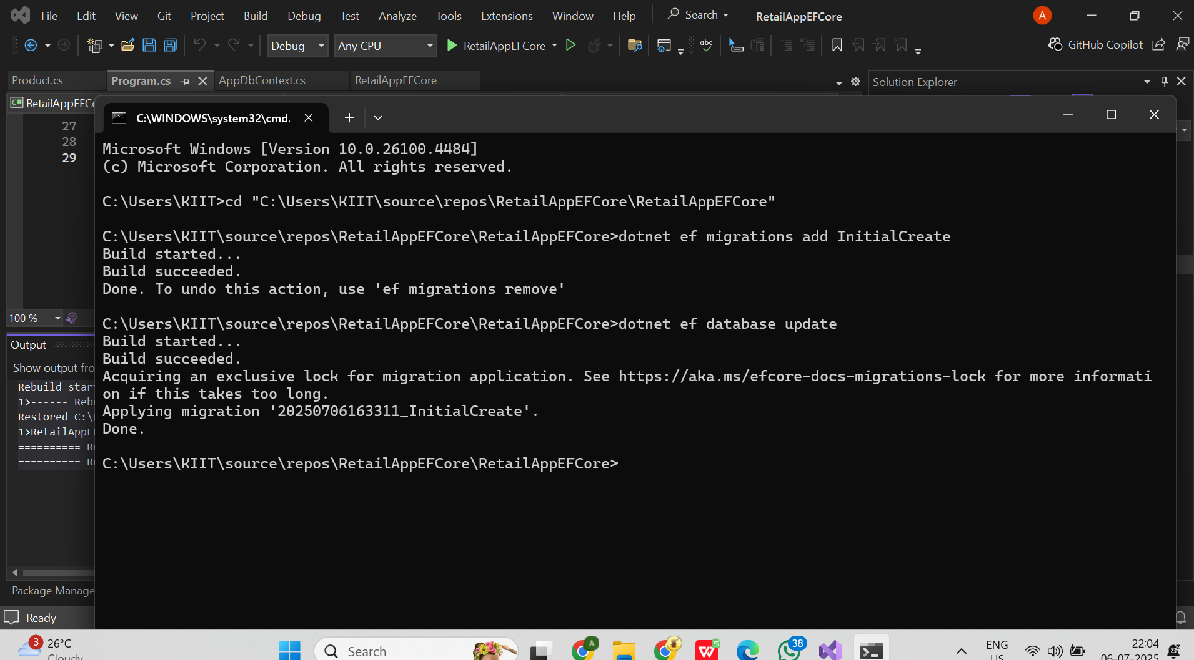

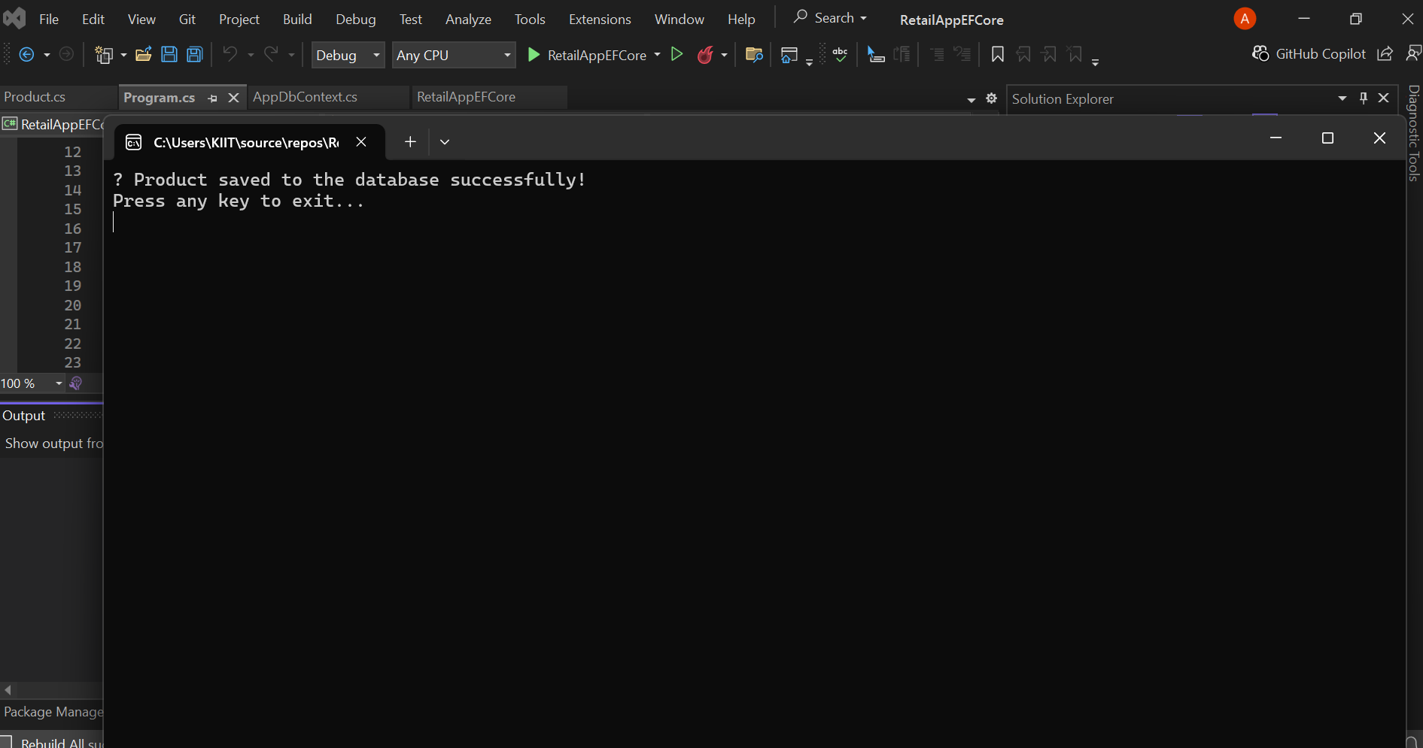

Lab 2: Setting Up the Database Context

Code

Category.cs
csharp
CopyEdit
namespace RetailAppEFCore
{
public class Category
{
public int Id { get; set; }
public string? Name { get; set; }

public ICollection<Product>? Products { get; set; }
}
}

🛒 Update Product.cs
Modify your existing Product class to link with Category:
csharp
CopyEdit
namespace RetailAppEFCore
{
public class Product
{
public int Id { get; set; }
public string? Name { get; set; }
public decimal Price { get; set; }

// Foreign key relationship
public int CategoryId { get; set; }
public Category? Category { get; set; }
}
}

🧑‍💼 File: Customer.cs
csharp
CopyEdit
namespace RetailAppEFCore
{
public class Customer
{
public int Id { get; set; }
public string? Name { get; set; }
public string? Email { get; set; }

public ICollection<Order>? Orders { get; set; }
}
}

📦 File: Order.cs
csharp
CopyEdit
using System;
namespace RetailAppEFCore
{
public class Order
{
public int Id { get; set; }
public DateTime OrderDate { get; set; }

public int CustomerId { get; set; }
public Customer? Customer { get; set; }
}
}

🧠 Update AppDbContext.cs
using Microsoft.EntityFrameworkCore;
using RetailAppEFCore.Models; // ✅ Added this to fix CS0246 errors

namespace RetailAppEFCore
{
public class AppDbContext : DbContext
{
public DbSet<Product> Products { get; set; }
public DbSet<Category> Categories { get; set; }
public DbSet<Customer> Customers { get; set; }
public DbSet<Order> Orders { get; set; }

protected override void OnConfiguring(DbContextOptionsBuilder optionsBuilder)
{
optionsBuilder.UseSqlServer(@"Server=(localdb)\mssqllocaldb;Database=RetailInventoryDb;Trusted_Connection=True;");
}
}
}

Screenshots

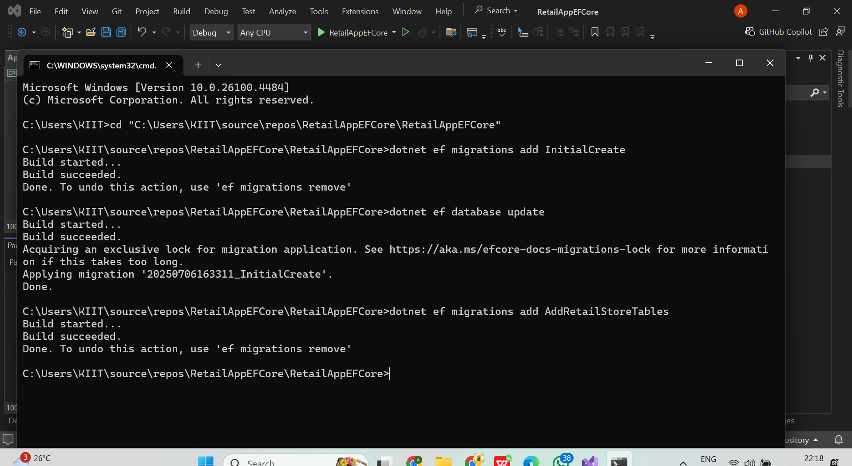

Lab 3: Using EF Core CLI to Create and Apply Migrations
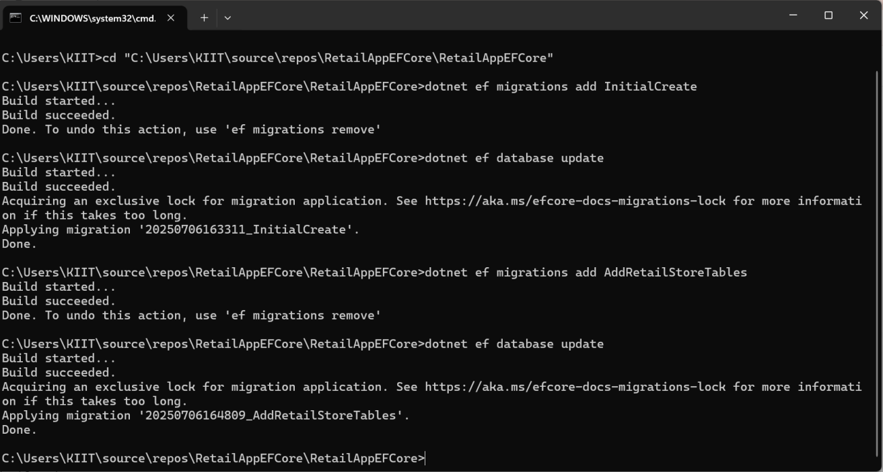

Lab 4: Inserting Initial Data

Code

Updated Program.cs
csharp
CopyEdit
using System;using System.Linq;using RetailAppEFCore.Models;
namespace RetailAppEFCore
{
class Program
{
static void Main(string[] args)
{
using var context = new AppDbContext();

// ✅ Prevent duplicate data
if (!context.Categories.Any())
{
// Insert Categories
var electronics = new Category { Name = "Electronics" };
var clothing = new Category { Name = "Clothing" };
context.Categories.AddRange(electronics, clothing);
context.SaveChanges();

// Insert Products
var product1 = new Product { Name = "Laptop", Price = 55000, Category = electronics };
var product2 = new Product { Name = "T-Shirt", Price = 499, Category = clothing };
context.Products.AddRange(product1, product2);
context.SaveChanges();

// Insert Customer
var customer = new Customer { Name = "Ananya", Email = "ananya@example.com" };
context.Customers.Add(customer);
context.SaveChanges();

// Insert Order
var order = new Order
{
Customer = customer,
OrderDate = DateTime.Now
};
context.Orders.Add(order);
context.SaveChanges();

Console.WriteLine("✔️ Initial data inserted successfully.");
}
else
{
Console.WriteLine("ℹ️ Sample data already exists. No insertion performed.");
}
}
}
}

Screenshot
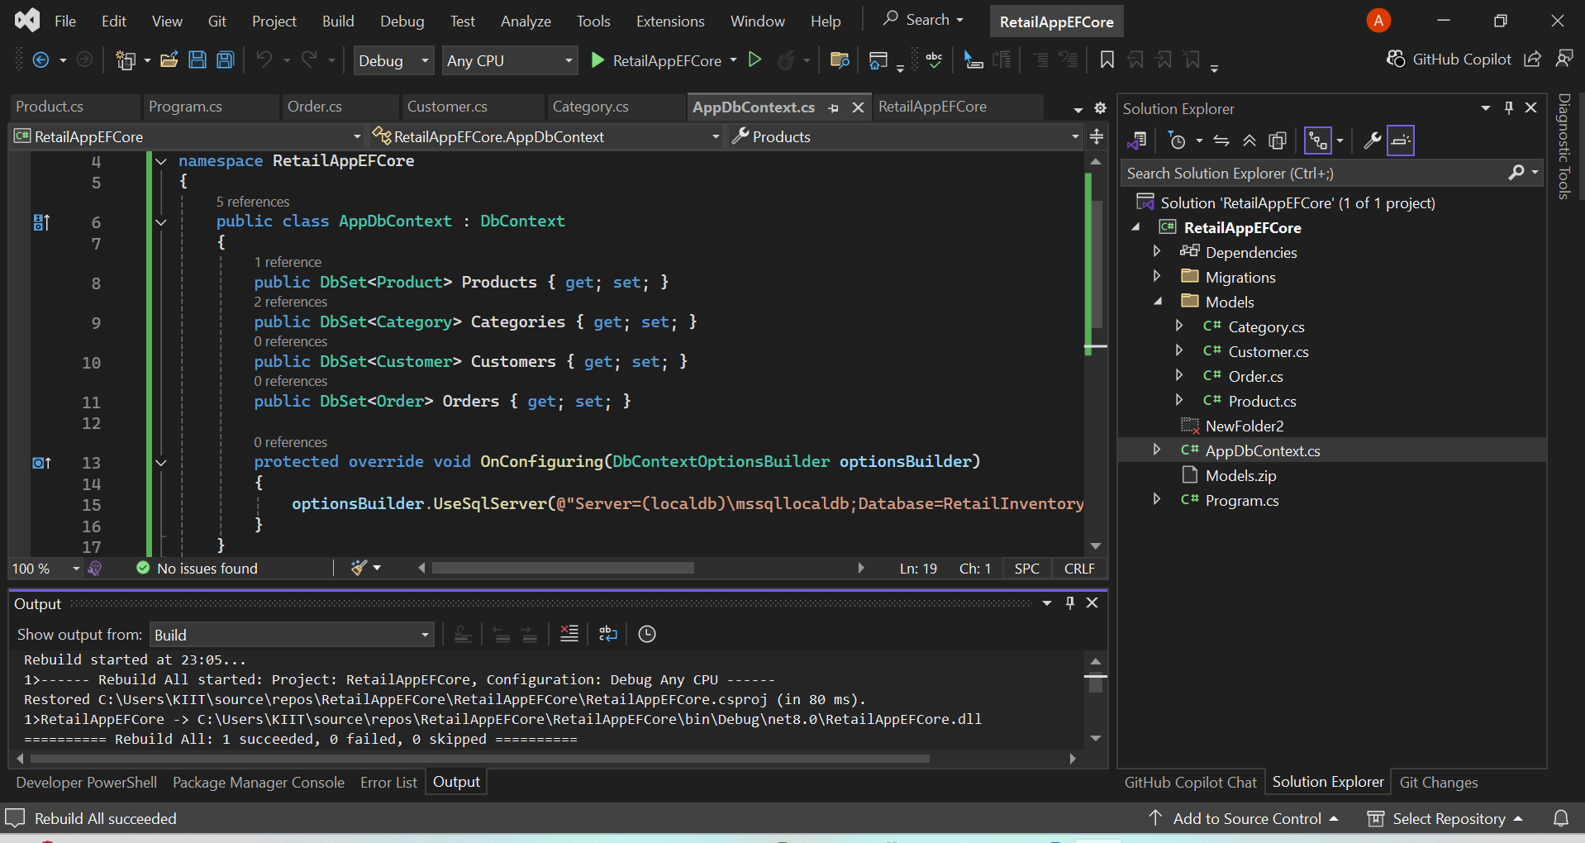

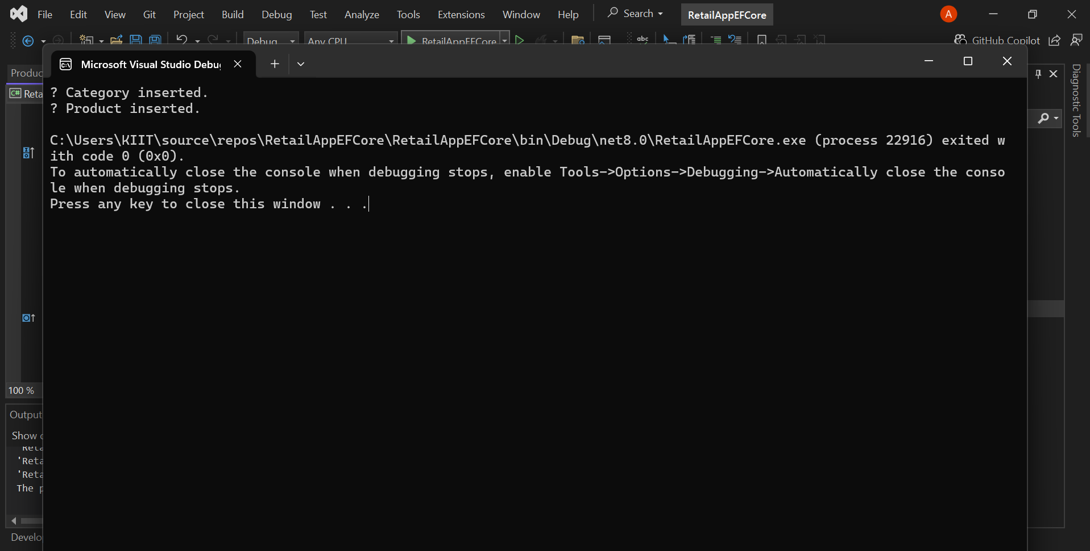

Lab 5: Retrieving Data with LINQ

Code

Program.cs (Lab 5)
csharp
CopyEdit
using System;using System.Linq;using RetailAppEFCore.Models;
namespace RetailAppEFCore
{
class Program
{
static void Main(string[] args)
{
using var context = new AppDbContext();

Console.WriteLine("📦 All Products:");
var products = context.Products.ToList();
foreach (var product in products)
{
Console.WriteLine($"- {product.Name} | ₹{product.Price}");
}

Console.WriteLine("\n🧑‍💼 Customers and Their Orders:");
var customers = context.Customers.ToList();
foreach (var customer in customers)
{
Console.WriteLine($"Customer: {customer.Name} ({customer.Email})");
var orders = context.Orders
.Where(o => o.Customer != null && o.Customer.Id == customer.Id)
.ToList();
Console.WriteLine($" Orders: {orders.Count}");
}

Console.WriteLine("\n🔍 Products in Category: Electronics");
var electronicsProducts = context.Products
.Where(p => p.Category != null && p.Category.Name == "Electronics")
.ToList();
foreach (var product in electronicsProducts)
{
Console.WriteLine($"- {product.Name} | ₹{product.Price}");
}

Console.WriteLine("\n✅ Data retrieval complete.");
}
}
}

Screenshot
